CAMPUS EVENT FINANCIAL PLANNING Python Case Study

Problem Statement
Design a Python program to estimate the financial feasibility of a campus event. The program receives fixed event costs, per-participant costs, expected registrations, registration fee and sponsorship. It computes total cost, income, surplus or shortfall, and the minimum number of registrations required to break even. Invalid negative numeric inputs must be rejected.

2. Objectives
• Read event name and eight numeric financial inputs.
• Validate that costs, participants, fee and sponsorship are non-negative.
• Separate fixed and per-participant variable costs.
• Calculate total event cost, participant contribution, income and balance.
• Classify the outcome as surplus or sponsorship shortfall.
• Use a while loop to find minimum registrations when break-even is possible.

3. Assumptions
• All amounts are in Indian rupees (Rs.) and inputs are numeric.
• Venue, equipment and transport are fixed costs; catering and certificate expenses apply per participant.
• Every expected participant pays the same registration fee; no additional income or expenses are considered.
• Sponsorship is a fixed amount, independent of participant count.
• Zero participants and zero-valued financial inputs are allowed; negative numeric values are invalid.
• A non-negative balance is labeled financially successful, including exactly break-even.
• Minimum registrations are calculated using the same fee and variable cost for every additional participant, with no capacity limit.
• The original program uses repeated addi
4. Formulas
• Fixed cost = venue + equipment + transport
• Variable cost per participant = catering + certificate
• Total cost = fixed cost + participants × variable cost
• Participant contribution = participants × registration fee
• Total income = participant contribution + sponsorship
• Balance = total income − total cost
• Amount needed = fixed cost − sponsorship Campus E

5. Step-by-Step Algorithm

1. START and read event name.
2. Read venue, equipment, catering, transport, certificate, participants, registration fee and sponsorship.
3. If any numeric input is negative, display Invalid input and STOP.
4. Calculate fixed_cost and variable_cost.
5. Calculate total_cost, contribution, total_income and balance
. 6. Display event name, total cost, contribution, sponsorship and income.
7. If balance ≥ 0, display financially successful and surplus; otherwise display sponsorship shortfall = −balance.
8. Calculate amount_needed = fixed_cost − sponsorship and margin = registration_fee − variable_cost
. 9. If amount_needed ≤ 0, print minimum registrations = 0.
10. Else if margin ≤ 0, print break-even is not possible
. 11. Otherwise initialize minimum = 0; while minimum × margin < amount_needed, increment minimum by 1.
12. Print minimum registrations and STOP

Flowchart
START
Input event and all financial values
Any negative number? YES: Invalid input, STOP
Compute fixed and variable costs
Compute total cost, contribution, income, balance
Print report and surplus / shortfall
Compute amount_needed and margin
amount_needed <= 0? Minimum = 0
Otherwise margin <= 0? Break-even impossible
Else minimum = 0; increment while
minimum × margin < amount_needed
Print result and STOP
Decision branches are summarized inside the flowchart boxes. The while-loop returns to its condition until the required amount is covered.

PSEUDO CODE
BEGIN
INPUT event, venue, equipment, catering, transport
INPUT certificate, participants, registration_fee, sponsorship
IF any numeric input < 0 THEN
PRINT "Invalid input"
ELSE
fixed_cost <- venue + equipment + transport
variable_cost <- catering + certificate
total_cost <- fixed_cost + participants * variable_cost
contribution <- participants * registration_fee
total_income <- contribution + sponsorship
balance <- total_income - total_cost
PRINT event, total_cost, contribution, sponsorship, total_income
IF balance >= 0 THEN
PRINT "Financially Successful", balance
ELSE
PRINT "Sponsorship Shortfall", -balance
ENDIF
amount_needed <- fixed_cost - sponsorship
margin <- registration_fee - variable_cost
IF amount_needed <= 0 THEN
PRINT "Minimum Registrations: 0"
ELSE IF margin <= 0 THEN
PRINT "Break-even is not possible"
ELSE
minimum <- 0
WHILE minimum * margin < amount_needed DO
minimum <- minimum + 1
ENDWHILE
PRINT minimum
ENDIF
ENDIF
END

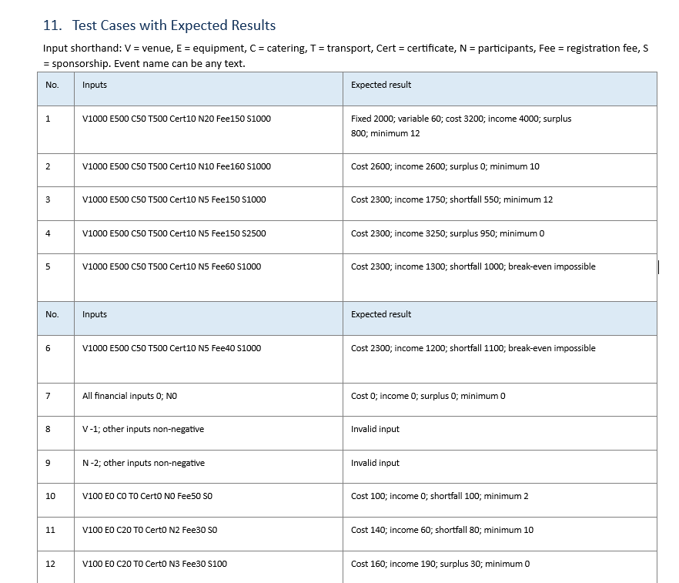

MY OUT PUT
The program demonstrates financial planning with Python fundamentals, input validation, conditional decisions, arithmetic, string output and a while loop. The break-even calculation distinguishes sponsorship already covering fixed costs from cases in which additional participants can or cannot cover the remaining cost.
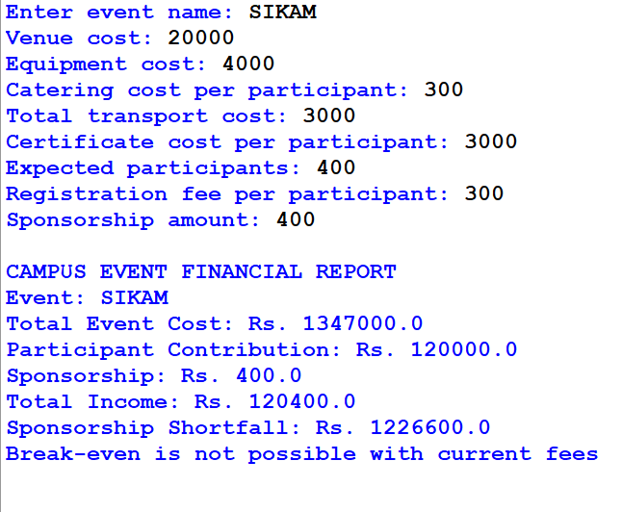

CONCLUSION

The program demonstrates financial planning with Python fundamentals, input validation, conditional decisions, arithmetic, string output and a while loop. The break-even calculation distinguishes sponsorship already covering fixed costs from cases in which additional participants can or cannot cover the remaining cost.

